Sammy Mehtar

Paper Outline:

* **Abstract**
* **Introduction**
  + Background (from lit review and other papers)
    - War
    - PH in war
      * Fragile states
      * Attacks on Healthcare
      * Comparison to other conflicts
    - ID
      * Measles
      * Diarrhea
        + ABD
        + AWD
        + Other AD
      * Polio?
    - Healthy Systems in Syria
      * Prior
      * During

* **Objectives and Methods**
  + Setting
    - Syria
    - Opposition-held territories, mostly in the north
    - Climate: seasonality, weather, geography
    - Location of sites, how many, why they were selected
  + Case Definition
    - WHO definitions (what year?)

Measles:

**Clinical case definition**:

* Any person in whom a clinician suspects measles infection, **or**
* Any person with fever **and** maculopapular rash (i.e. non-vesicular) **and** cough, coryza (i.e. runny nose) or conjunctivitis (i.e. red eyes).

**Laboratory criteria for diagnosis:**

* Presence of measles-specific IgM antibodies.

**Case classification**

* Countries are advised to use the clinical classification scheme until their programmes meet the following two criteria:
  + low levels of measles incidence;
  + access to a proficient measles laboratory.
* The laboratory classification scheme should be used by countries in the low incidence or elimination phase.
* **Clinical classification scheme**
  + ***Clinically confirmed***: A case that meets the clinical case definition.
  + ***Discarded***: A suspect case that does not meet the clinical case definition.
* **Laboratory classification**
  + ***Laboratory-confirmed***: A case that meets the clinical case definition and is laboratory-confirmed.
  + ***Epidemiologically-confirmed:*** A case that meets the clinical case definition and is linked epidemiologically to a laboratory-confirmed case

**Recommended minimum data elements**

**Aggregated data:**

* Number of cases by age groups and immunization status
* Number of measles vaccine doses administered to infants aged under 12 months
* and children aged 12–23 months.

In every phase, completeness and timeliness of monthly (mortality reduction

phase) or weekly (low-incidence or elimination phase) measles reporting should be monitored.

**Recommended data analyses, presentations, reports**

**Mortality reduction phase**

* Number of cases and incidence rate by month and year, and geographical area
* Age-specific, sex-specific and district-specific incidence rates.
* Measles vaccine coverage by year and geographical area.
* DTP1–measles or BCG–measles dropout rate.
* Completeness/timeliness of monthly reporting.
* Proportion of known outbreaks confirmed by the laboratory.

**Principal uses of data for decision-making**

* **Mortality reduction phase**: Monitor incidence and coverage to assess progress (i.e. decreasing incidence and increasing coverage) and identify areas at high risk or with poor program performance. Describe the changing epidemiology of measles in terms of age, immunization status and interepidemic period. Assist in determination of optimal age groups to be targeted by second opportunity for measles vaccination (including mass vaccination campaigns).
* **Low-incidence or elimination phase**: Identify chains of transmission. Monitor the epidemiology (age groups at risk, interepidemic period, immunization status) of measles and accelerate immunization activities accordingly to avert potential outbreaks. Use epidemiological data to classify cases (see special aspects section). Use performance indicators to assess the quality of surveillance and identify areas that need strengthening.
* **During all phases**: Detect and investigate outbreaks to ensure proper case management, and determine why outbreaks occurred (e.g. failure to vaccinate, vaccine failure or accumulation of susceptibles).
  + Study population
    - “The study population consisted of every outpatient presenting at any of the sentinel sites who met the ILI case definition, regardless of age or sex”
  + Surveillance system
    - EWARN: Early Warning And Response Network
    - Based off the WHO supported EWARS model
    - EWARS is a streamlined sentinel surveillance program that can be rapidly deployed in humanitarian or conflict settings during the acute phase of an emergency. Designed as a temporary measure when public health information systems are disrupted or non-functional. The program is meant to be reintegrated into a national or regional system after the public health information systems have regained capacity.
    - EWARN has been active for 5 years and has gained great experience and expertise. They operate in opposition-held territories in Syria. The WHO collaborates with the Syrian ministry of health to operate a separate EWARS program in government-held territories in Syria.
    - Tracks 13 syndromes based on 1) their potential to cause epidemics, 2) association with high morbidity and mortality, and 3) the existence of interventions in Syria.

|  |  |  |
| --- | --- | --- |
| Abbreviation | Clinical Syndrome | Suspected Disease |
| ABD | Acute Bloody Diarrhea | Shigellosis |
| AWD | Acute Watery Diarrhea | Cholera |
| AD | Other Acute Diarrhea |  |
| AJS | Acute Jaundice Syndrome | Hepatitis A & E |
| ILI | Influenza-Like Illness | Influenza |
| SARI | Severe Acute Respiratory Illness | Avian Influenza A (H7N9), MERS-CoV, other |
| AFP | Acute Flaccid Paralysis | Poliomyelitis |
| MEA | Suspected Measles | Measles |
| MEN | Suspected Meningitis | Bacterial Meningitis |
| STF | Suspected Typhoid Fever | Typhoid |
| LEISH | Leishmaniasis | Cutaneous Leishmaniasis |
| UCE | Unusual Cluster of Health Events |  |
| UCD or UXD | Unusual Cluster of Deaths |  |

* + Weekly zero-reporting: every week, reports for all of these conditions across the coverage areas are consolidated by subdistrict. If no cases are recorded in a region, then it is reported as zero, to distinguish it from missing data.
  + Alert thresholds: trigger a report to the health working group and an investigation.
    - Type A: immediate notification for the existence of certain diseases (e.g. measles, UCD, AFP, ABD in camps)
    - Type B: Based on trend analysis of aggregated data that suggests an unexplained increase (e.g. outbreak of LEISH or STF, ABD not in the camps)
    - Alerts help identify early stages of an outbreak in a community or facility.
  + Data Flow: Health centers document cases in patient registers, a Field Level Officer (FLO) collects the surveillance data from each health center in the field in Syria and sends it to a District Level Officer (DLO) also in Syria who then consolidates the data for each district and sends the data for each week to a Central Level Officer located in at the ACU headquarters in Gaziantep, Turkey for analysis, interpretation, and dissemination.
  + Quality is assessed by the completeness and timeliness of each report.
  + Inclusion of health facilities: Due to the volatile situation in Syria, only selected health facilities will be included in the weekly aggregation of data for sentinel surveillance. Efforts will be made to ensure representativeness; however, priority will be given to the following health facilities:
    - Adequate resources
      * Staff – physician, surveillance officer or focal point
      * Resources – patient registers, method of communication
    - Stability and security
    - Accessibility
    - Sentinel sites will be evaluated periodically to determine the addition/removal of health facilities based on performance indicators (timeliness, completeness, regularity of reporting).
    - Temporary institutions will not be included.
  + Data collection:
    - Key principles when recording diseases:
      * Strictly adhere to the EWARN case definitions. These may differ from previous surveillance case definitions and from clinical case definitions. For example, acute diarrhea should not be confused with suspected cholera.
      * Only assign one main health disease/syndrome to each patient.
      * Only record new cases during weekly aggregation of data.
      * If a patient presents to the health facility for the same condition multiple times, this is considered a repeat visit and should only be counted once.
      * If a patient is transferred from another health facility, only count as a new case if the referring health facility is not part of EWARN
  + Data management and analysis
    - Reports were documented and consolidated using [excel].
    - Statistical tests and software:
      * R
    - Geospatial analysis
      * ArcGIS
  + Population Estimates: UN OCHA
  + Interpretation of surveillance data: by person, place, time:
    - Contingency table
      * Sick vs not sick, exposed vs unexposed
      * Vaccinated vs unvaccinated, attacked vs unattacked
    - Attack rate (incidence)
      * (cases in 1 week in given population)/(population)
    - Proportion of cases under 5 vs over 5
    - Trends (Excel or R)
      * Use language from the Cholera or measles papers
    - Spatial mapping
      * ARC GIS or R -> talk to Patty
      * Spatial analysis of diseases and attacks
    - Modeling
      * Log-linear (R)
        + GLM/poisson
        + What GLM does: <https://www.r-bloggers.com/what-does-a-generalized-linear-model-do/>

m <- glm(y~x1+x2,data=d,family=binomial(link='logit'))

summary(m)

* + Regions:
    - Eastern Aleppo: lost in 2016
    - Homs: Lost in 2017(?), besieged before
    - Idlib: Main region of opposition, some of most consistent data.
    - Ar-Raqqa: ISIS 2016-2018
    - Damascus: Government control, no access
    - Others: I need more info
  + PHR data
    - How it was collected (Sayaka)
    - Stat analysis (X2? Linear regression?)
      * By region, disease, age, gender
  + Interviews?
    - Qualitative data

* **Results**
  + Lit review
  + Characteristics of the study population
    - Age, sex, regional distribution (SD, mean, range)
    - Maps, Table 1
  + Distribution of VPD
    - Measles
    - Age, sex, regional distribution (SD, mean, range)
    - Maps, Table 1
      * Seasonality
      * Describe trends over time qualitatively and quantitatively
        + Growing annual outbreaks

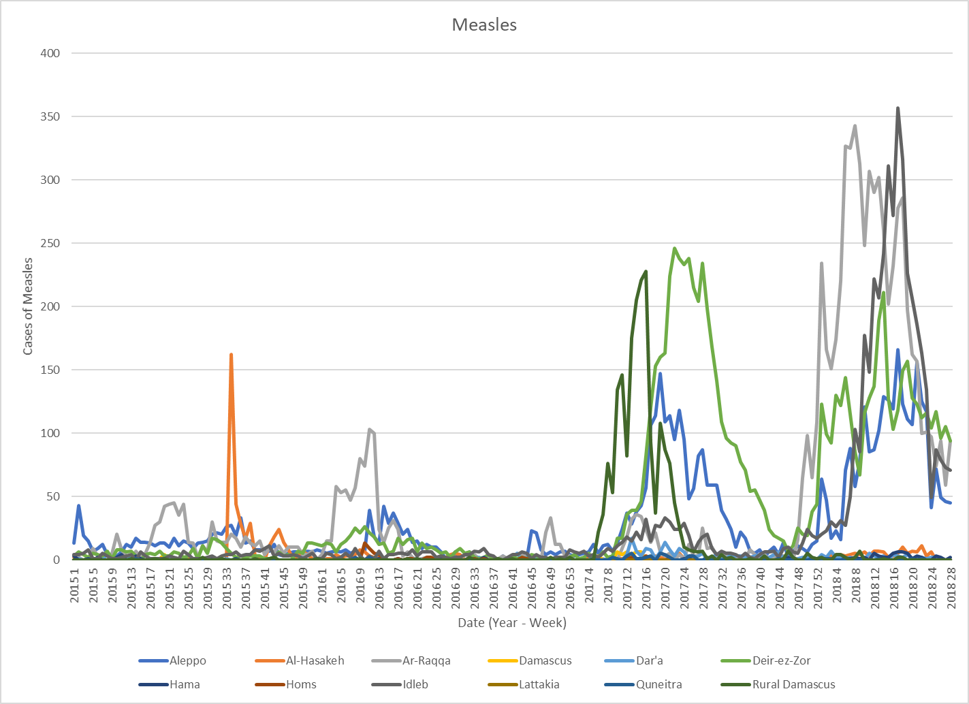

* + - Polio?
  + Diarrhea?
    - Acute Bloody
    - Acute Watery
  + Leishmaniasis?
  + Total consultations
    - Before war/after war start
    - After major events in districts
    - By age and gender
  + Performance of surveillance
    - Timeliness
    - Completeness
    - Zero-reporting
  + Attacks on Healthcare facilities (PHR)

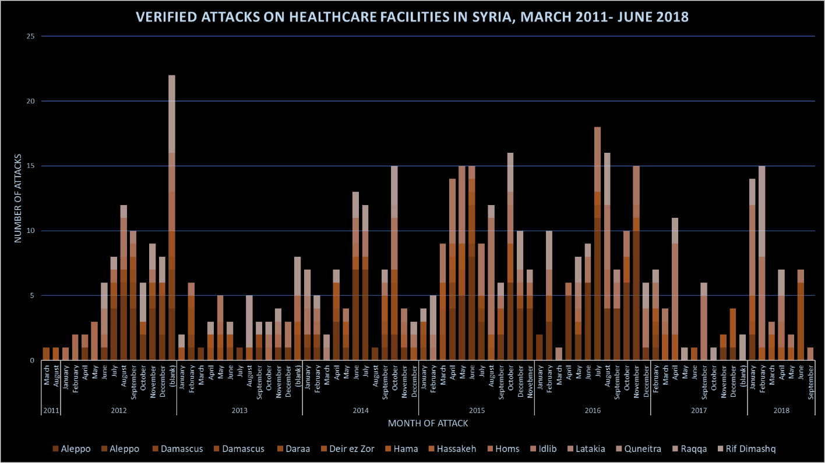

* **Discussion:**
  + Key findings
    - Trends
    - Peak activity
    - Distribution
  + Timeline of key events
    - Conflict
    - Attacks on health
    - Vaccination campaigns (SIA)
    - Other interventions (WASH, etc)
  + Hypotheses
    - WASH:
      * Due to the crisis in Syria since 2011, water supplies, water quality monitoring systems, solid waste collection and sanitation systems from residential areas have been affected by the lack of services and the collapse of some systems, which resulted in the increase of WBD and environmental sanitation. This requires a new system able to work within emergency conditions, and do the works that was done by the services institutions (Water and Sanitation Association – Municipal Councils) – (from EWARN Guidelines)
    - VPD:
      * As a part of health sector collapse during the Syrian crises, the decline in vaccination coverage resulted in the re-emergence for VPDs as multiple outbreaks in different areas. Measles outbreaks appeared at start of 2013 and polio reemerge in the end of 2013 , as well as for other VPDs such as pertussis, mumps, T.B and hepatitis B. All those diseases were rare before National Immunization Program was interruption in many areas. The Early warning alert and response Network (EWARN) played a major role in the investigation and sampling process, thus confirming them. Therefore, the cross borders vaccination activities became a necessity in northern of Syria, later on the Syrian Immunization Group (SIG) was formed by the involvement of the humanitarian organizations and the supervision of WHO and UNICEF. The EWARN participated and joined the group as a member. – (from EWARN Guidelines)
  + Ethics: Excluded
  + Limitations
    - Ecological study design
    - Attacks limited to attacks on facilities, and not all are captured
    - Difficult/impossible to disentangle other effects of conflict on public health
    - No consistent baseline to compare to
    - May not be generalizable
    - Impact of conflict on integrity of data collection
    - Limited access to many regions
    - Dynamic population
  + Limitations
  + Further research
* **Conclusion**
  + How does this contribute to our understanding/new knowledge?
  + Summarize what was learned
  + Recommendations
* **References**

_______

Inclusion Criteria

* WASH
* VPD
  + Keep STF on both
  + What vaccines routinely used
* Map out population and coverage GIS
* Timeline of events
* Incidence of all
* Focus on one WASH disease
* Focus on one VPD disease (measles)
  + Break down by pop characteristics
  + Incidence vs total
  + R correlation coefficient
* Overall trends
* Attack on facilities
  + Interrupted time series
  + Poisson
* DLab: Talked to Evan Muzzal

________

Notes on eco study design:

Ecological Study Design

* Variables
  + Independent
  + Dependent
  + Interdependent
    - A set of related variables that are presumed to covary in a meaningful way.
    - A common example is a community data set consisting of n sites by p species abundances, arranged in a two-way data matrix in which the rows represent the sites and the columns represent the species. In this case, the species are the variables and there is no distinction of independent and dependent. In fact, they are all presumed to be interdependent on each other since they presumably covary in meaningful ways. Moreover, they are generally considered to be inter-dependent variables because they are presumed to respond to other perhaps unmeasured independent variables that are not part of this variable set.

* Data types in eco:
  + Continuous
    - Regression
    - Analysis of variance
  + Counts
    - Log-linear models
    - Contingency tables
    - 3.2 Count data

Count data is a form of discrete data in which the observations can take only the non-negative integer values {0, 1, 2, ...}, and where these integers arise from counting rather than ranking. Count data is usually of one of two forms:

1) simple counts, e.g., the number of plants infected by a disease on a plot, the number of eggs in a nest, etc., and

2) categorical data, in which the counts are tallied for one or more categorical explanatory variables, e.g., the number of plants infected in each of several towns.

* With simple counts, the goal is usually to explain or predict the counts based on one or continuous independent or explanatory variables, and the method of generalized linear modeling is used for this purpose.
* With categorical data, the goal is usually to determine whether the distribution of counts among categories differs from expected, and the method of contingency table analysis employing log-linear modeling is often used for this purpose.

* Proportions
  + Proportion data is another form of discrete data in which we know how many of the observations are in one category (i.e., an event occurred) and we also know how many are in each other category (i.e., how many times the event did not occur). This is an important distinction, since it allows the data to be represented as proportions instead of frequencies, as with count data.
  + There are lots of ecological examples of proportion data: percent mortality, percent infected, sex ratio, etc..
  + The key distinction of proportion data is that the frequency of the event, e.g., individual died, is known as well as the total number of events, e.g., total number of individuals.
  + With proportion data, the goal is typically to explain or predict the proportional response based on one or more explanatory variable, and the method of logistic regression is designed for this purpose.
  + Note, here the explanatory variables are measured for each sample trial, as opposed to each individual. This is an important distinction between proportion data and binary data.

* Binary data
  + Binary data is data in which the observations can take only one of two values, for example, alive or dead, present or absent, male or female, etc..
  + Binary data is useful when you have unique values of one or more explanatory variables for each and every observational unit; this is an important distinction from proportional data in which the explanatory data is collected at the level of the trial (consisting of many observational units).
  + Binary data is typically analyzed with the method of logistic regression, like proportion data.

* Time at death
* Time series
* Circular data



Best Studies to model off:

* Cholera in Yemen Report
* Cholera Surveillance During Haiti Epidemic, Barzilay et al., 2013
* Identifying Humanitarian crises in population surveillance field sites, Fottrell and Byass, 2008
* 
* Epidemiological Surveillance of Poliomyelitis During the Military and Political Conflict in the Central African Republic 2013 and 2014, Farra et al., 2016

<https://www.who.int/immunization/monitoring_surveillance/resources/surveillance_publication/en/>